Name : Prerana Kamankar

Roll No : CS2-14

PRN : 202401040082

EDS Activity 1 : Movie review dataset

________________________________________________________________________

Problem statements :

1) Find the average revenue per year.

2) Find the average runtime of movies.



3) Find the director with the most movies.



4) Find how many movies have the genre 'Action'.



5) Find the correlation between Rating and Revenue.



6) Find the percentage of movies with a rating greater than 7.



7) Find the movie(s) with the longest runtime.

8) Replace all NaN values in the Revenue column with the column mean.

9) Group movies by Director and find the average rating of their movies.

10) Find the number of missing values in each column

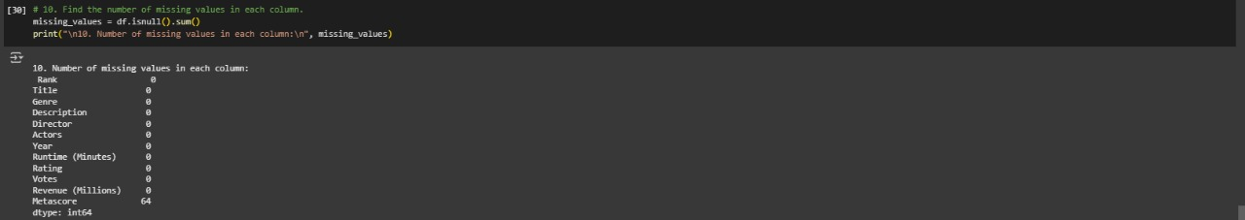

11)Find the number of rows and columns in the dataset.

12) Display the first 5 rows of the dataset.

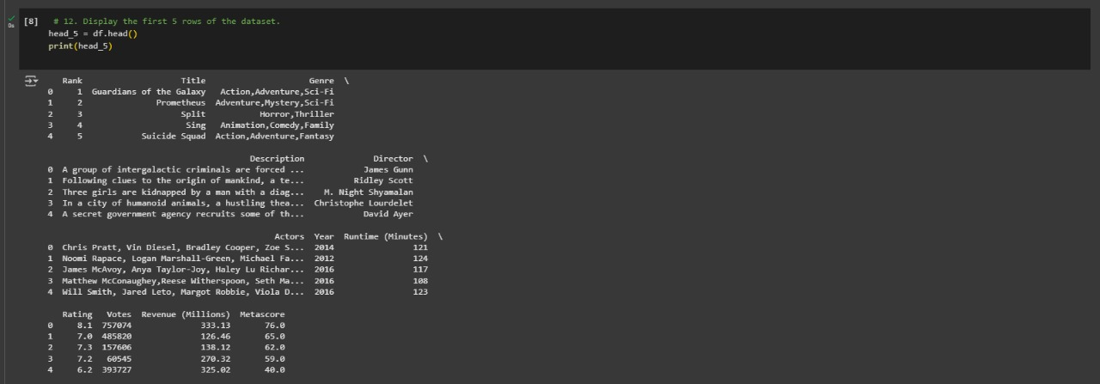

13) Find the list of unique genres in the dataset.

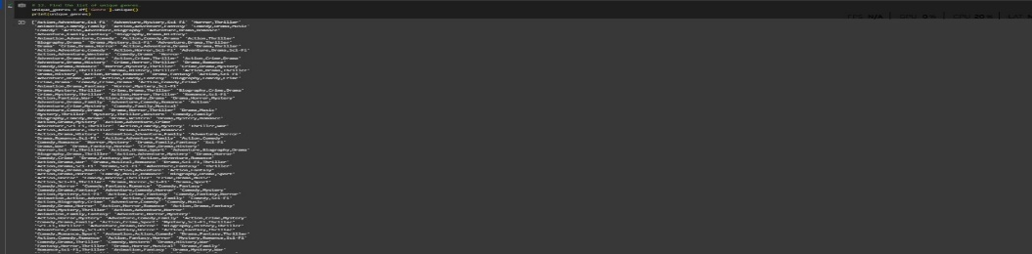

14) Find the average rating of all movies.



15) Find the movie with the highest revenue.

16) Find the movie with the lowest revenue.

17) Calculate the total revenue generated by all movies.



18) Find how many movies have a rating above 8.



19) List the top 10 movies based on revenue.

20) Find how many movies were released each year.

